### Eastern Africa

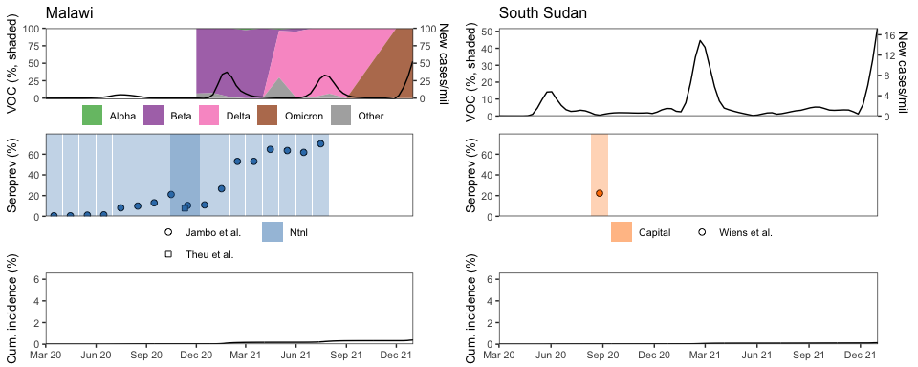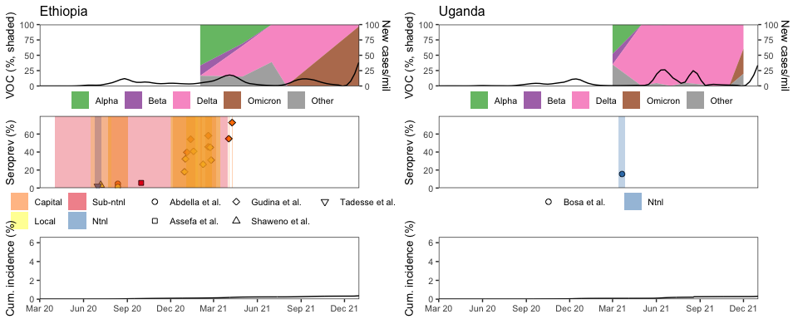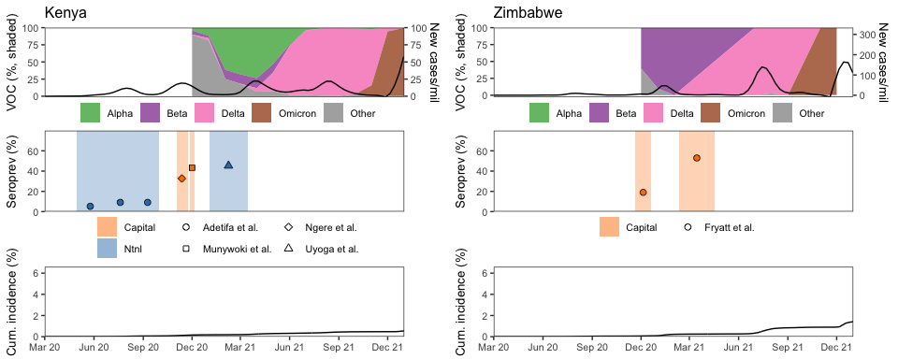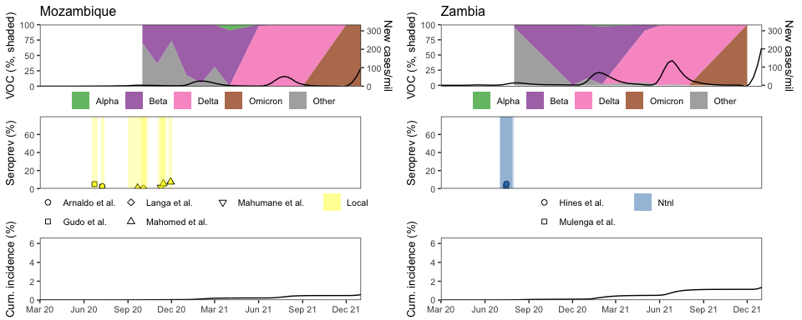

### Southern Africa

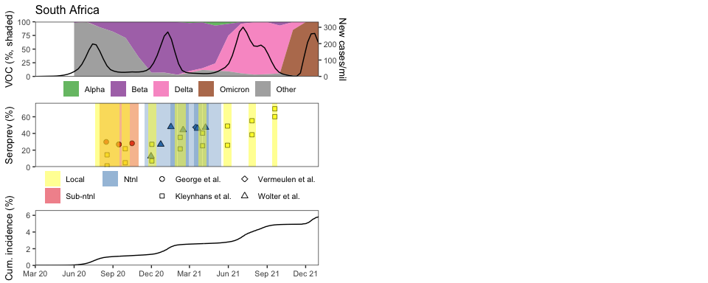

### Western Africa

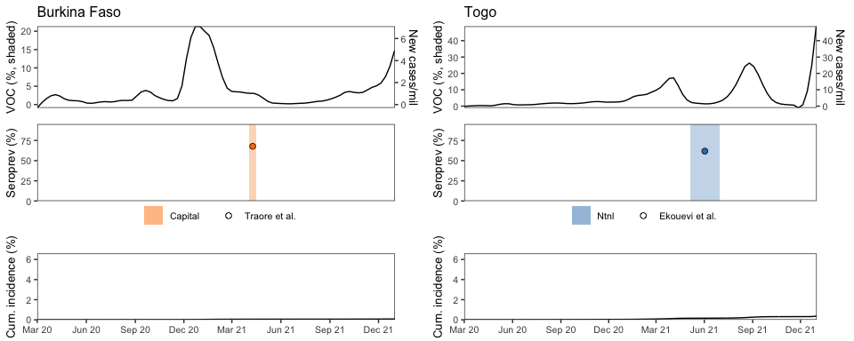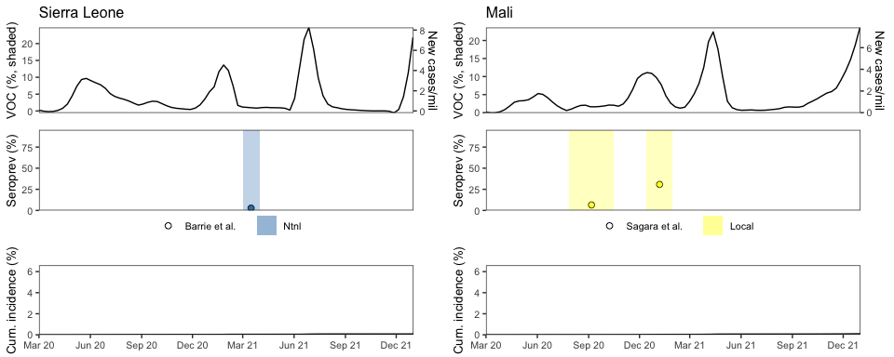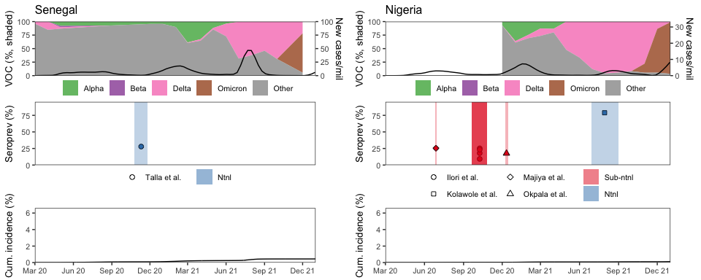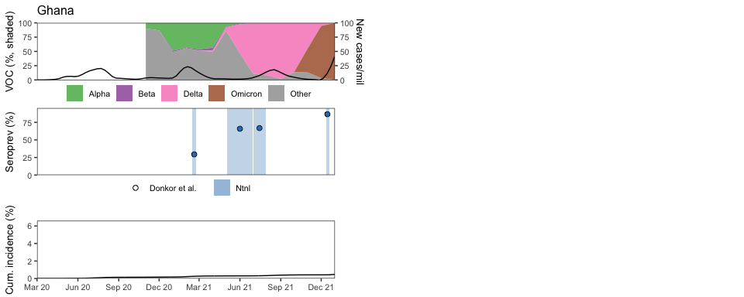

### Middle Africa

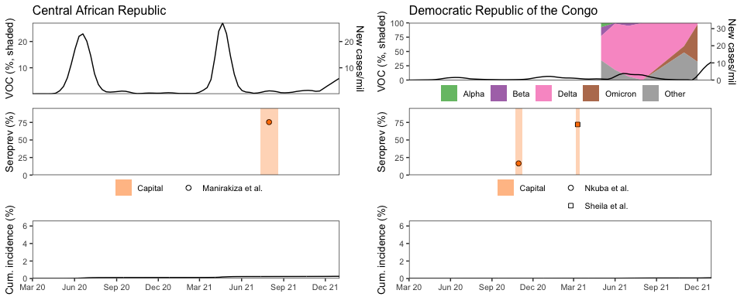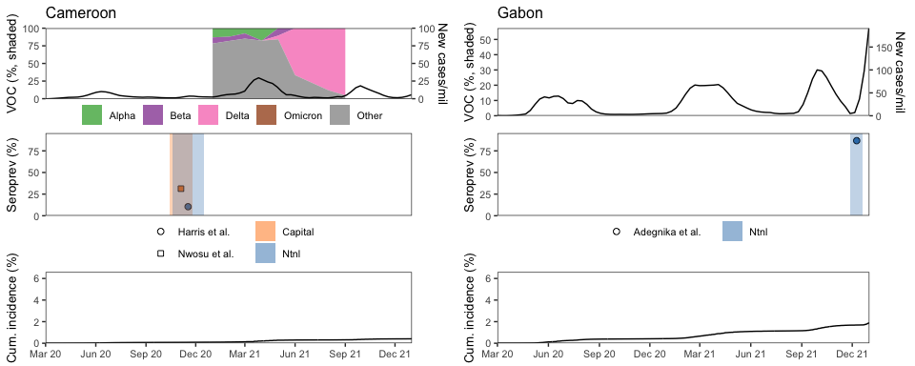

## $`1`

##   
## $`2`

##   
## $`3`

##   
## $`4`

##   
## attr(,"class")  
## [1] "list" "ggarrange"

## $`1`

##   
## $`2`

##   
## $`3`

##   
## $`4`

##   
## attr(,"class")  
## [1] "list" "ggarrange"

## $`1`

##   
## $`2`

##   
## attr(,"class")  
## [1] "list" "ggarrange"

## pdf   
## 2

## pdf   
## 2